Supplemental material
Figure S1. The nucleotide and deduced amino acid sequences of BsfDuox cDNA of black soldier fly
FigureS2. The nucleotide and deduced amino acid sequences of BsfTLR3 cDNA of black soldier fly
FigureS3. The domain structures of the BsfDuox in black soldier fly
FigureS4. The domain structures of the BsfTLR3 in black soldier fly
FigureS5. Expression profiles of the BsfDuox and BsfTLR3 at different development stages
Figure S6. Influence of oral inoculation of pathobionts to RNAi effects of the BsfDuox gene
(A) Expression levels of the BsfDuox gene in ds-Duox-TLR3 and ds-egfp treated larvae 16 hours after oral infection with S. aureus
(B) The total intestinal ROS levels in ds-Duox-TLR3 and ds-egfp treated larvae 16 hours after oral infection with S. aureus
(C) Expression levels of the BsfTLR3 gene in ds-Duox-TLR3 and ds-egfp treated larvae 16 hours after oral infection with S. aureus
Data are representative of three independent experiments (mean + SEM). Statistical comparison was based on Student’s t-test (* p<0.05, ** p<0.01, *** p<0.001) N.S. means no significance
Figure S7 Rarefaction curve and rank-abundance curve based on bacterial OTUs at dissimilarity level of 3%. (A) Rarefaction curve. (B) Rank-abundance curves
Figure S8. Principal coordinate analysis based on weighted UniFrac metrics.The result showed a separation of ds-Duox-TLR3 and ds-egfp-treated samples along the first two axes, which explained 53.07% and 13.77% of the data variation, respectively. (A) 3Dscore plot of the ds-Duox-TLR3 RNAi and ds-egfp RNAi sample (B) 2D biplots on PC1–PC2 plane overlapping scores and loadings
Figure S9 The different expression level of Bsfdorsal after feeding 24 h with different concentrations H₂O₂. Values are the mean ± s.e.m. of three independent experiments. Different letters indicate a significant difference in Bsfdorsal expression (p<0.05)

Table S1 Primers used in this study
Application | Gene name | Primer name | Primer sequence(5'-3')
qPCR  analysis | BsfDuox | DuoxF | CAGACGCCGTTCAGACAC
 |  | DuoxR | ATCGCATCATTTCGCTCA
 | BsfTLR3 | TLR3F | CGCCATTGTCCCTACTTG
 |  | TLR3R | AACCGTGATGTTGCTGAT
 | BsfCecropin | CecropinF | AAGAGTTCGTGATGCTGGTA
 |  | CecropinR | ATTGGCTCCTTGTTGTGC
 | BsfDLP4 | DLP4F | ACCTGCAAGGATTCTGGG
 |  | DLP4R | GCTGTGCCGCTAAACTCG
 | BsfDefencin | defencinF | ACGACTCCACATCTGGCG
 |  | defencinR | GTCATCGCACCATCCTCC
 | BsfUbiqiutin | UbiqiutinF | AGCATAGAAATGACGGGA
 |  | UbiqiutinR | AATTGGTGGATCGACAGC
 | BsfStomoxynZH1 | StomoxynZH1F | AACTCGCCATTGTCCTTT
 |  | StomoxynZH1R | CTCCAGCTAATCCTTCCAC
 | Bsfdorsal | dorsalF | ATGAATGCGAAGGACGAT
 |  | dorsalR | CCTCACGAGCACGAAGTG
 | Bsfdif | difF | ATGAATGCGAAGGACGAT
 |  | difR | CCTCACGAGCACGAAGTG
 | Bsfb-actin | b-actinF | AAACCTTCAACGCCCCAGC
 |  | b-actinR | GGCGTGTGGAAGAGCATAACC
 | 16SDNA  gene-specific  primers | 16SDNAgF | ACTCCTACGGGAGGCAGCAG
 |  | 16SDNAgR | ATTACCGCGGCTGCTGG
 | b-actin DNA  primers | b-actin  DNAF | AGGCTCCACTCAACCCAA
 |  | b-actin  DNAR | GCCAAATCCAGACGCAAG
dsRNA  synthesis | dsBsfDuox | dsBsfDuoxF | TAATACGACTCACTATAGGGGGGTTCGTCTATCCTGC
 |  | dsBsfDuoxR | TAATACGACTCACTATAGGGCCTGAGTACCGATT
 | dsBsfTLR3 | dsBsfTLR3F | TAATACGACTCACTATAGGGCGCCATTGTCCCTACTTG
 |  | dsBsfTLR3R | TAATACGACTCACTATAGGGAACCGTGATGTTGCTGAT
 | dsegfp | ds-egfpF | TAATACGACTCACTATAGGGTCGTGACCACCCTGACC
 |  | ds-egfpR | TAATACGACTCACTATAGGGTCACCTTGA

Figure S1
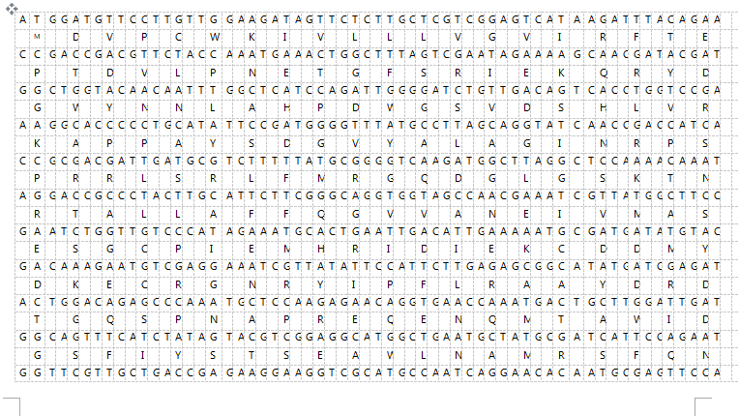
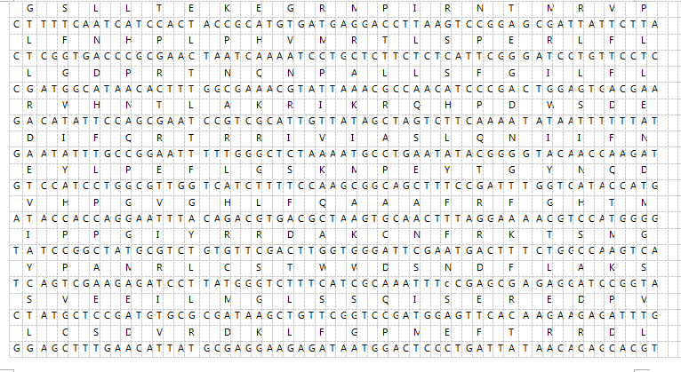
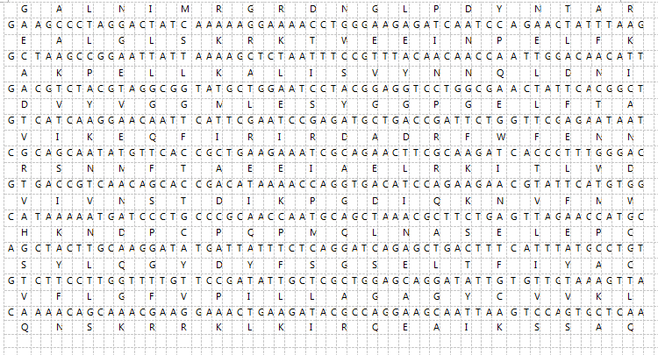
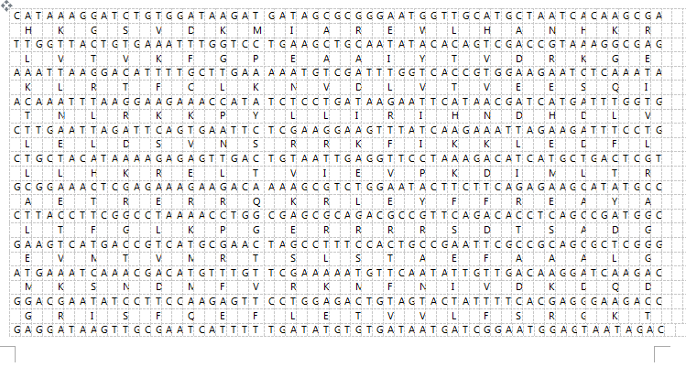
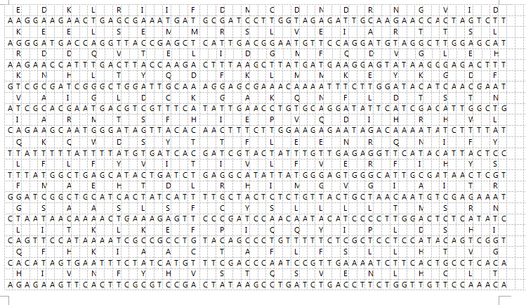
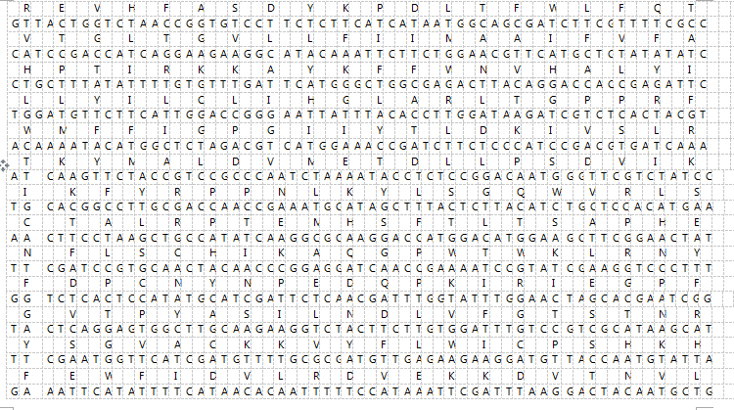
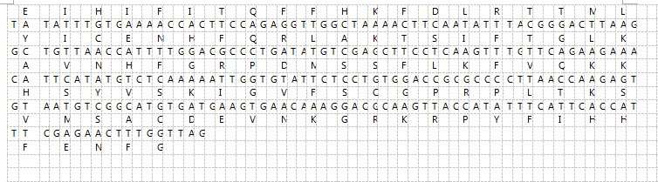

FigureS2
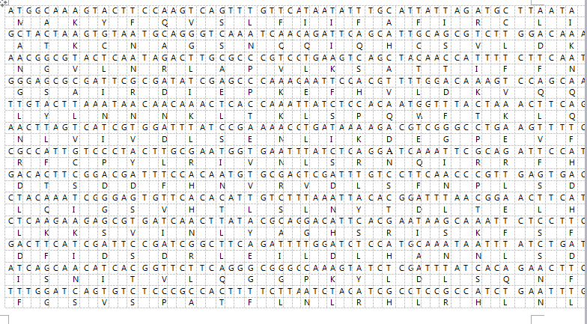

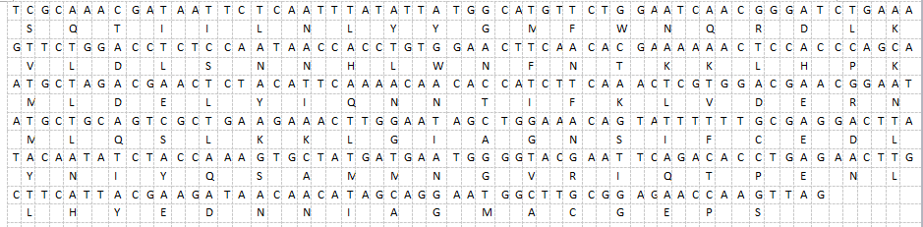

FigureS3

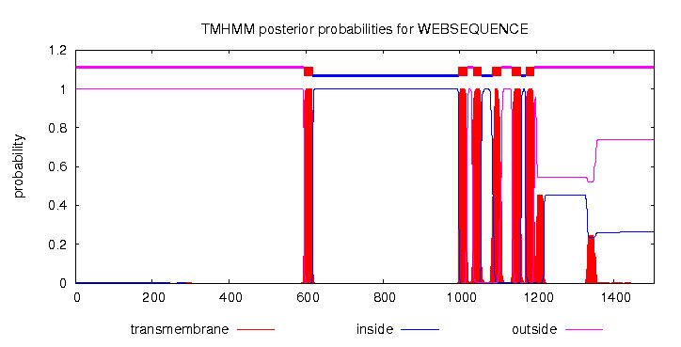

FigureS4

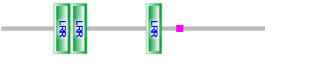

Figure S5

Figure S6

Figure S7

Figure S 8

Figure S9

